PASSWORD GENERATOR

21CSS101J – PROGRAMMING FOR PROBLEM SOLVING

Mini Project Report

Submitted by

Kaavya Manohar [Reg. No.: RA2211003010166]
B.Tech. CSE - Core

Kamalesh D [Reg. No.: RA2211003010170]
B.Tech. CSE - Cores


TABLE OF CONTENTS

Chapter No. | Title | Page No.
1 | Problem Statement | 1
2 | Methodology / Procedure | 2
3 | Coding (C or Python) | 3
4 | Results | 4
5 | Conclusion | 5

Problem Statement

- Design a program to generate a mechanism for logging on to a network or service using a unique password.

- To generate a random string of characters using a combination of lowercase, uppercase, digits and special characters to form a password.

Methodology / Procedure

- By importing the array module and also the random module we can generate random choices in the list of alphabets, digits or special characters and hence we’re then generating a password that follows the characteristics of a strong password.

- By user input we can specify the length of password of our choice.

- Declare arrays of the character that is required in the password and must be Represented as characters to enable easy string concatenation.

- A combined list of all the character arrays must be formed to form one array.

- Randomly select at least one character from each character set above by using random.choice

- Create a temporary password, convert the temporary password into an array and shuffle to prevent it from having a consistent pattern where the beginning of the password is predictable.

- Traverse the temporary password array and append the chars to form the password.

Coding (C or Python)

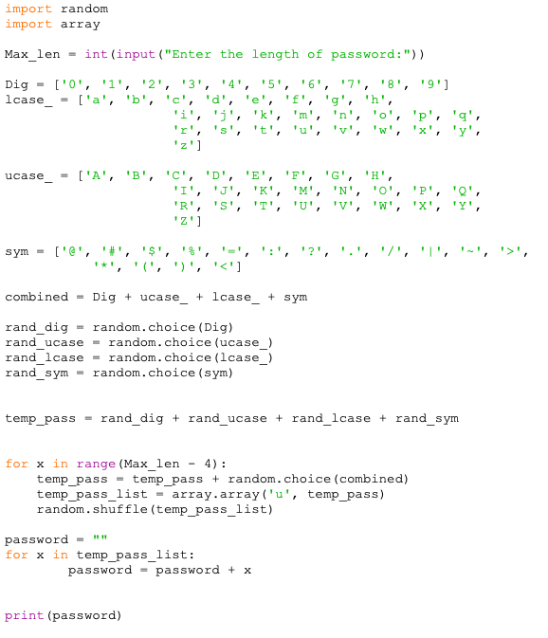

Results

The user input here is 15 so the password is 15 characters long.

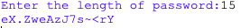

The user input here is 15 so the password is 15 characters long.

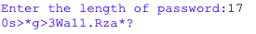

Conclusion

Hence the program is successfully executed. Using random and array modules.

